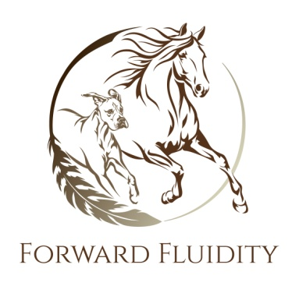

Consent for Equine/Canine Bodywork

I hereby apply for equine bodywork and/or energy work. I understand that the intent is to improve the functioning of my horse’s body and mobilize the energy; however, the work is not represented as a substitute for veterinary care.

I recognize that the process of this treatment necessitates that my horse’s body be touched, and I give permission to Shannon McBride of Forward Fluidity to touch my horse’s body. This consent form will apply to all equine bodywork/energy work sessions from this date forward unless revoked in writing.

I understand that Shannon McBride of Forward Fluidity cannot diagnose illness or lameness, nor prescribe treatments or medications, herbal or pharmaceutical.

To the best of my knowledge, I have given Shannon McBride all information of my horse’s health that I believe bodywork/energy work could affect, such as injuries, illness, surgeries, skin conditions and allergies. I agree to update Shannon McBride with any new information before each session.

Shannon McBride of Forward Fluidity reserves the right to reschedule an appointment if a horse is presenting any conditions or behaviors that would be contraindicative to bodywork.

I agree to accept financial responsibility for any appointments and am aware that there is a $65 fee for missed or cancelled appointments without 24 hours notice.

Name: ________________________________________

Address: ________________________________________________________

City: _____________________________ State: __________ Zip: ___________

Telephone (H): ___________________ (W): ______________________

Signature: ___________________________________________

Date: _______________

